Even * Semester (2024)

**BINUS UNIVERSITY BINUS INTERNATIONAL**

**Assignment Cover Letter (Individual Work)**

**Student Information**: ***Surname Given Names Student ID Number***

# Lie Karsten 2440035463

## 

## Course Code : COMP6699 Course Name : Object Oriented Programming

**Class :** L2AC **Name of Lecturer(s) :** Jude Joseph Lamug Martinez

**Major :** Computer Science

**Title of Assignment** : To Do Manager

(if any)

## Type of Assignment : Final Project

**Submission Pattern**

**Due Date :** 21-06-2021 **Submission Date :**

The assignment should meet the below requirements.

1. Assignment (hard copy) is required to be submitted on clean paper, and (soft copy) as per lecturer’s instructions.
2. Soft copy assignment also requires the signed (hardcopy) submission of this form, which automatically validates the softcopy submission.
3. The above information is complete and legible.
4. Compiled pages are firmly stapled.
5. Assignment has been copied (soft copy and hard copy) for each student ahead of the submission.

## Plagiarism/Cheating

BiNus International seriously regards all forms of plagiarism, cheating and collusion as academic offenses which may result in severe penalties, including loss/drop of marks, course/class discontinuity and other possible penalties executed by the university. Please refer to the related course syllabus for further information.

## Declaration of Originality

By signing this assignment, I/we* understand, accept and consent to BiNus International terms and policy on plagiarism. Herewith I/we* declare that the work contained in this assignment is my/our* own work and has not been submitted for the use of assessment in another course or class, except where this has been notified and accepted in advance.

Signature of Student: (Name of Student)

Karsten Eugene Lie

Table of Contents

1. Introduction 3

2. Project Specifications 3

2.1 Aim 3

2.2 Apps, Libraries, etc. 3

2.3 Languages 3

2.4 Features 3

3. UML Diagram 4

4. How It Works 5

4.1 First Start Up 5

4.2 Adding Tasks 6

4.3 1 Task Added 8

4.4 Multiple Tasks 9

4.5 Delete Task 10

5. Code 11

5.1 Navigation.java 11

5.2 ToDoData.java 12

5.3 TaskController.java 14

5.4 TaskCreationController.java 16

6. Project GitHub Link 18

7. Demo Video Link 18

8. Credits 18

**Project Name:**

**To Do Manager**

**Name:**

**Karsten Eugene Lie**

**ID:**

**2440035463**

# Introduction

To Do Manager is a simple To Do GUI where users can input their tasks. This program can be used by everyone who thinks that they need a To Do list on their computer and wants a simple and clean design for it with all the basic functionalities of a To Do list.

# Project Specifications

## 2.1 Aim

The aim of this project is the same as a normal to do list, reminding people of what to do in their day-to-day life, but just on a computer. This could be more beneficial for people who do most of their tasks on their computer so that they can keep the program open to always remind themselves of what they need to do. This program would also help with time management as users can decide when they want to do their tasks. There are also indications if the task is important so that users can prioritize those first.

## 2.2 Apps, Libraries, etc.

* Java (ver. 16.0.1)
* JavaFX (ver. 16.0.0)
* Scene Builder (ver. 16.0.0)

## 2.3 Languages

* Java
* CSS

## 2.4 Features

* Add tasks
* Delete tasks
* Displaying total tasks on home page
* Sort tasks by the due date, importance, or alphabetically (default of table view)
* Tasks are stored on the local computer (inside txt file)

# Diagram Description automatically generatedUML Diagram

The diagram above shows the UML diagram of the To Do Manager. We can see that all the controller classes implement the Initializable class. This class is used to initialize all the labels or texts to display as the scene is for that specific controller is opened. The controller classes also aggregate from the Navigation class. This class is created to prevent long duplicate codes and it is used to navigate between the tabs or scenes. There are also a lot of classes that aggregate the ToDoData class. This class is useful as it has the getInstance() method to access the other methods inside the class. Of course, the ToDoData class also aggregates the ToDoItem class as that is where new Tasks are created. After tasks are created, they are transferred to the ToDoData class to be added to a list.

# How It Works

## 4.1 First Start Up

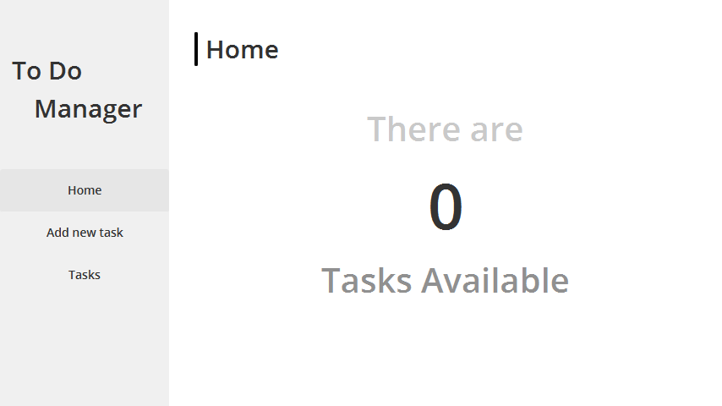

When the user first launches the GUI, they are introduced with the home screen that displays “There are 0 Tasks Available”. The digit will change depending on the number of tasks the user has made. From here, the user can go to the sidebar and click on “Add new task” or “Tasks”.

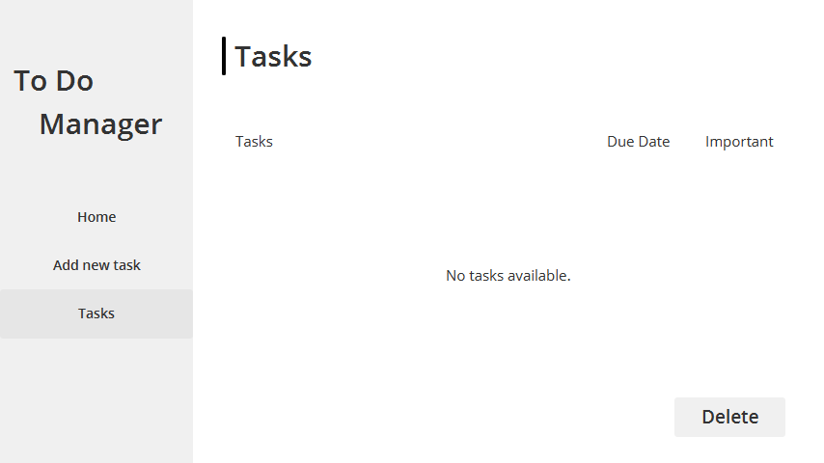

This is how the “Tasks” view will look like when there are no tasks added yet. In the middle of the table, a text saying, “No tasks available.” will be displayed.

## 4.2 Adding Tasks

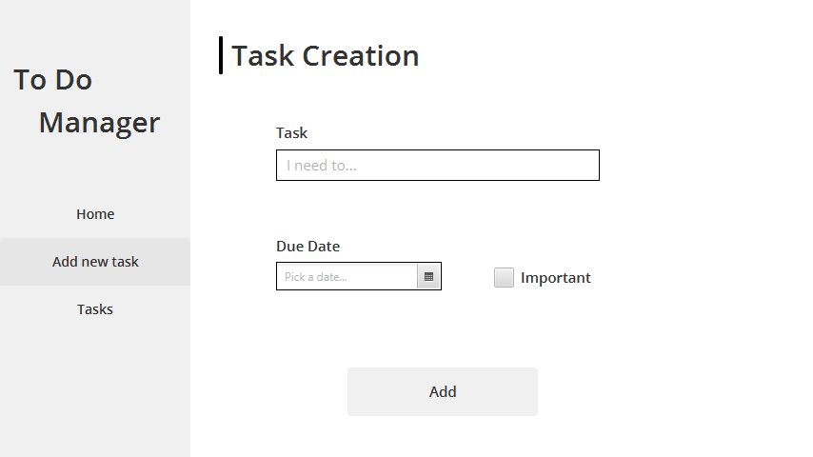

To add tasks users can click the “Add new task” button and they will be greeted with this screen. Here, a text field, a date picker, and a checkbox will be available for the user.

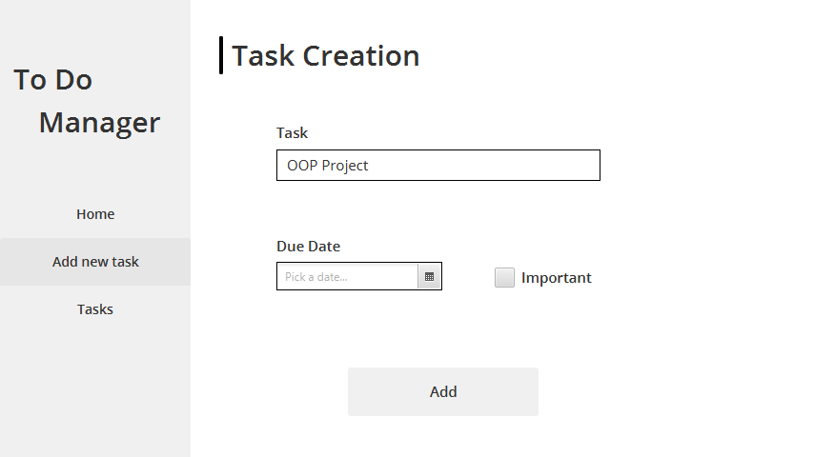

In the text field, the user can input their task title. In this example, I used OOP Project

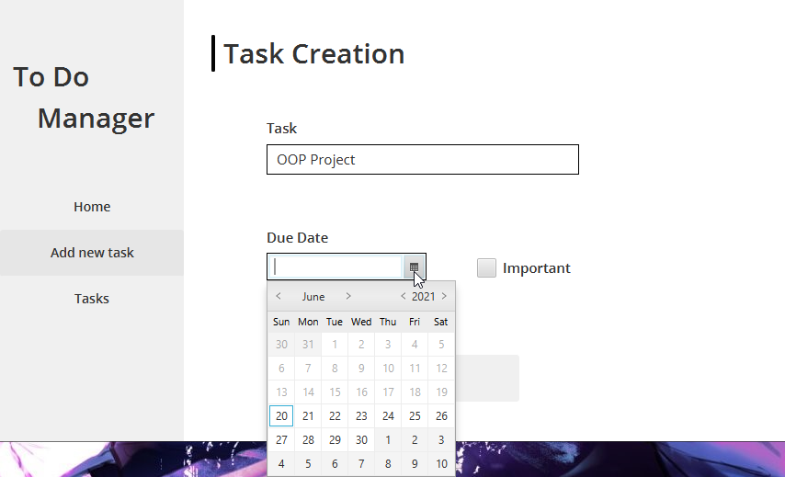

Next is the date picker. This is where users can pick their due date. The date picker also disabled the dates before today as it does not make sense for the due date to be on a day before the current day.

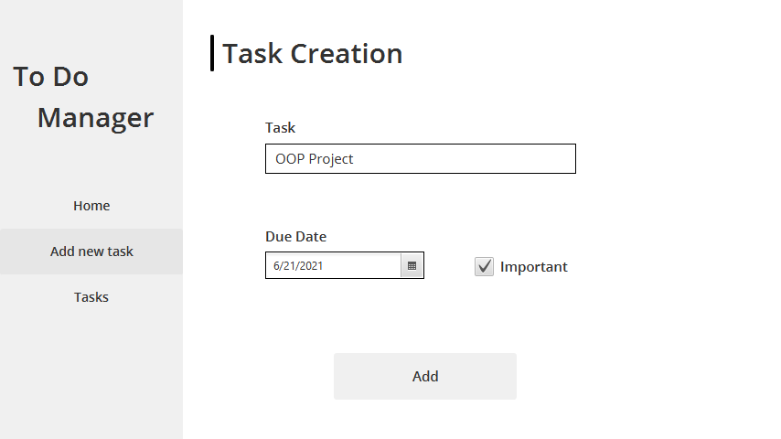

Once the user has chosen a date for the due date, the user can then check or leave the checkbox that says “Important”. This important checkbox is for tasks that the user thinks are important, and it will be marked on the “Tasks” tab later.

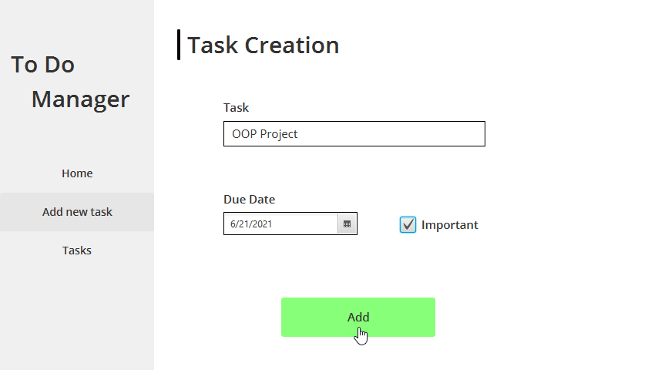

After the user filled everything correctly, the user can click the “Add” button. The button was initially grey, but once the user hovers on it, it will turn green. After clicking the button, the task will be added to the “Tasks” tab and a success message will appear on the top right. The program will also clear the user inputs to prepare for the next input.

## 4.3 1 Task Added

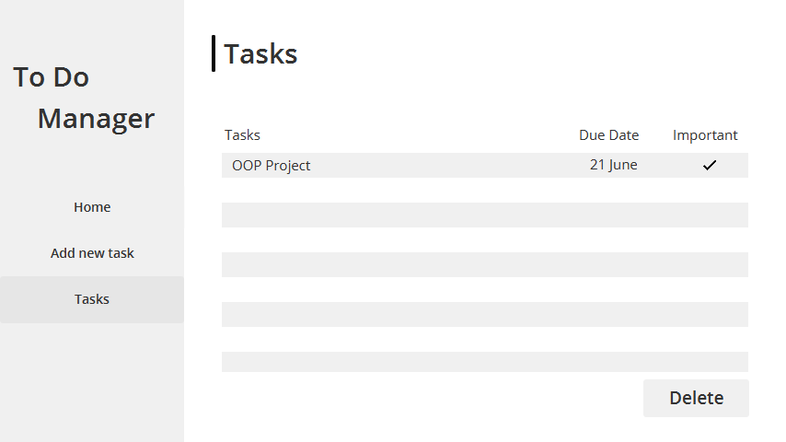

Once a task is added, it will show up on the “Tasks” tab in a table view, where users can see the “Tasks” column, which is for the task name, the “Due Date” column, which shows the due date, and the “Important” column, which shows a tick if the task is important. If the task is not important, nothing will show up on that column.

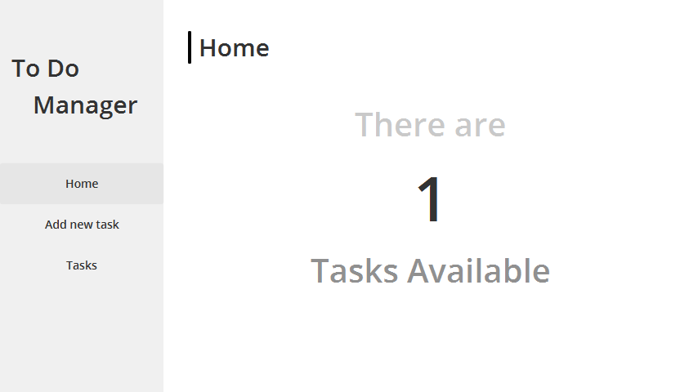

Other than the “Tasks” tab, the “Home” tab will also update. Since the user added 1 task, it will display that there is 1 task available.

## 4.4 Multiple Tasks

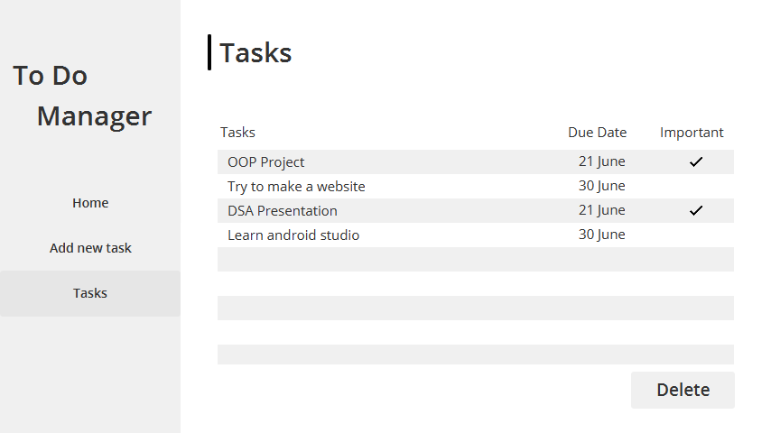

If the user has added a few other tasks, this would be how it would look in the “Tasks” tab. We can see the differentiation between tasks that are important and tasks that are not. The default order for the table is by the latest task added. The top being the first task added while the bottom is the last task added. The user can sort it by task name or due date or importance just by clicking on one of the column headers.

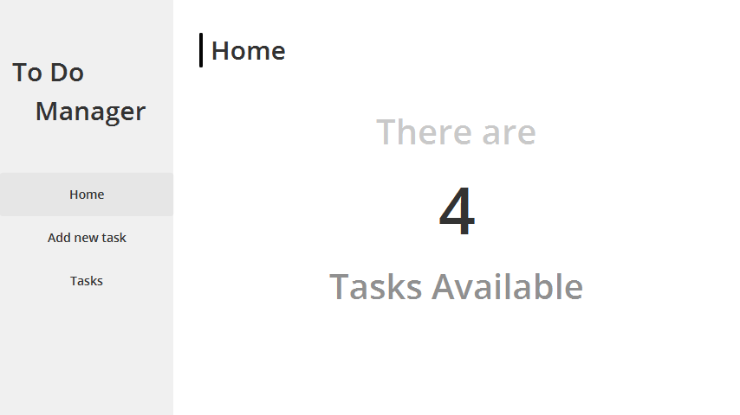

Again, the number of tasks will also be updated in the “Home” tab depending on how many tasks the user added.

## 4.5 Delete Task

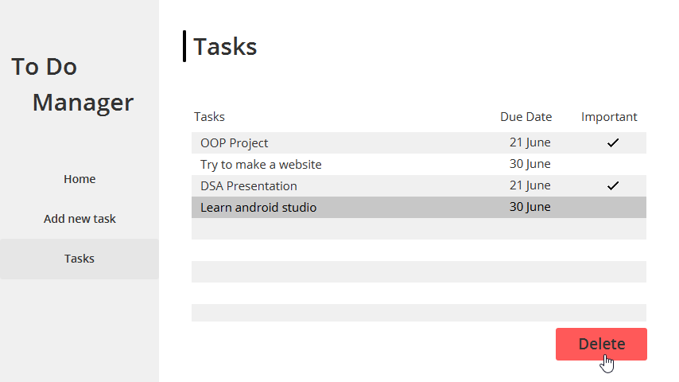

In the “Tasks” tab, the user also has the option to delete a certain task. All the user needs to do is click on one of the tasks and it will be highlighted by a darker grey highlight. Then the user can go to the delete button and click on it.

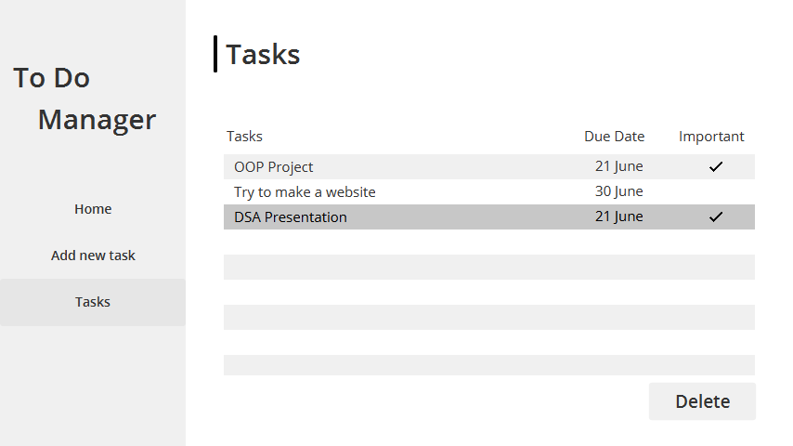

After the user presses delete, the task will instantly be removed from the table. And of course, the “Home” tab will also update the number of tasks available.

# Code

The codes displayed in this section will be codes that are not self-explanatory, in other words, codes that are a little complicated, or codes that are, what I think, are quite fascinating to look at.

## 5.1 Navigation.java

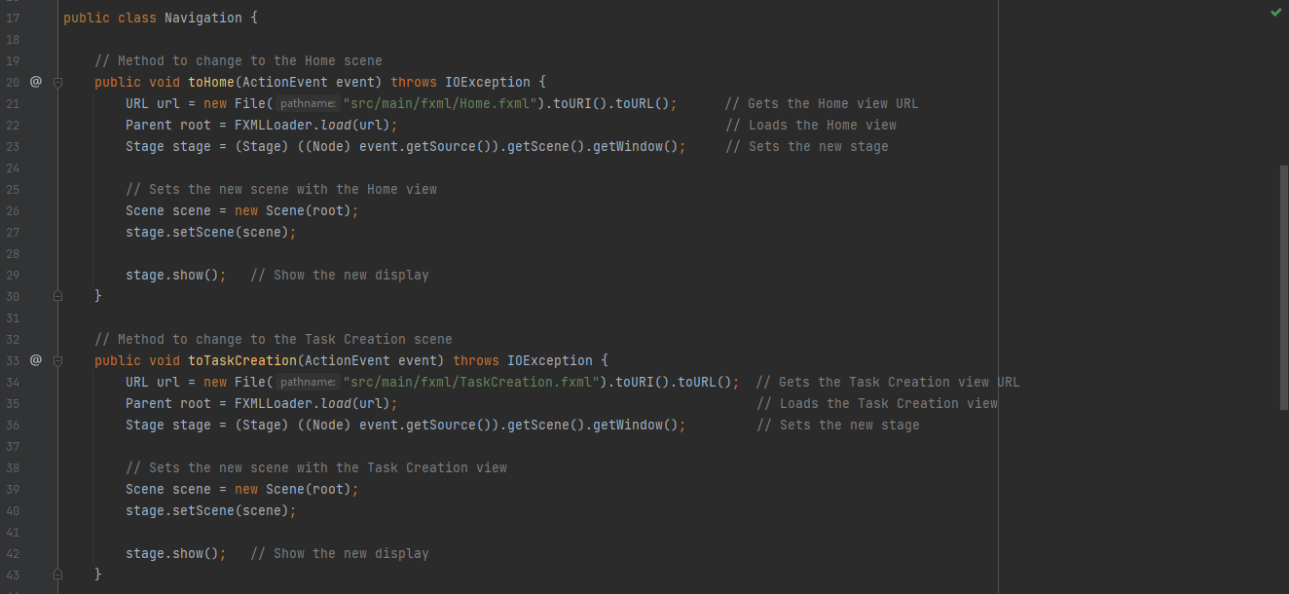

The Navigation class is a custom class that was aimed to prevent long duplicate codes inside the controllers. The methods in this class are basically to change scenes depending on what the user clicks (Home, Add new task, Tasks). First, it gets the URL of the FXML file, and it gets passed to the root. The method will then prepare a new stage and a new scene, where the root is passed in. Finally, it displays the stage.

## 5.2 ToDoData.java

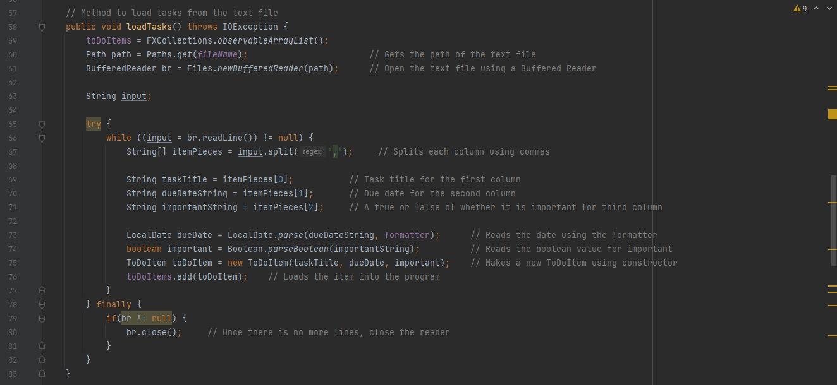

ToDoData is a custom-made class, and its aim was to deal with the processes of the ToDoItem (which is also a custom-made class). However, the main method that I will be displaying is **loadTasks()** and **storeTasks()**.

The screenshot above shows **loadTasks()**, which is a method to load tasks from previous sessions. This means when a user adds a few tasks and closes the program, the tasks will still be available when the user opens the program again. This method is possible by making a new instance of Buffered Reader and reading the “Tasks.txt” file. Inside the text file, each line contains 1 task, and each task is separated into 3 columns using a comma (,). Once it finishes reading all the lines, it will add it to the list of tasks and close the text file.

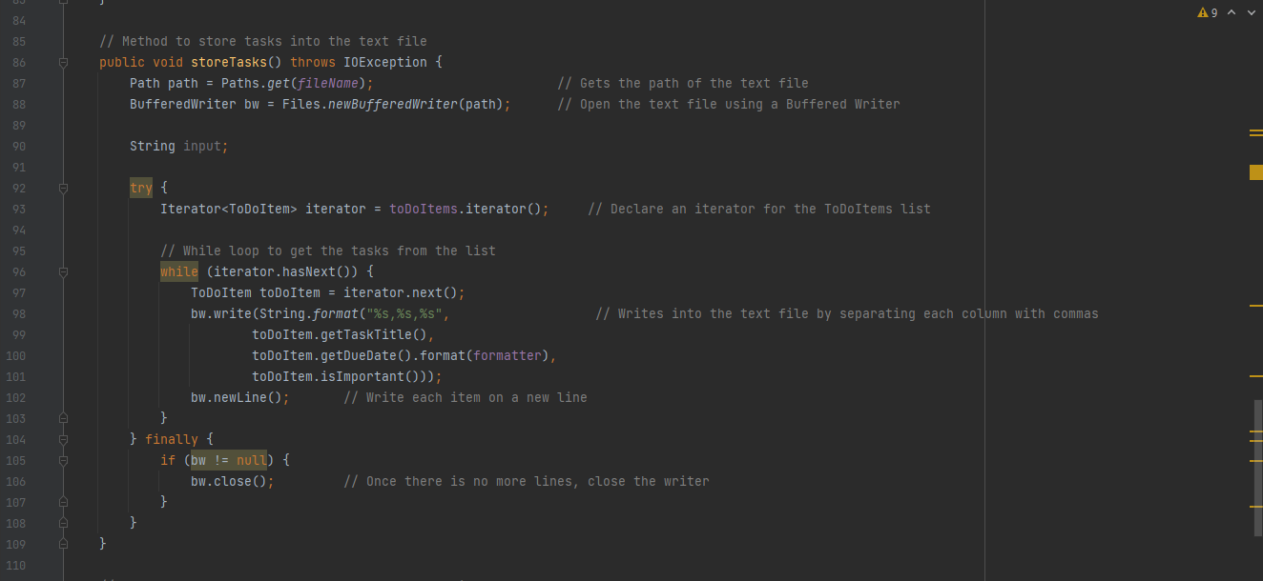

The code above is the **storeTasks()** method. This code does the opposite of **loadTasks()**. **loadTasks()** loads the task items every time the program starts, while **storeTasks()** stores the task items every time the program closes.To store tasks, I used Buffered Writer to write into the text file. First, it will create an iterator for the task items. Then it will iterate through each task and get their title, due date, and “important” variable and write into the text file, separating each variable with a comma. After that, it will move on to the next item. Once there are no items left, the text file will be closed.

Both **storeTasks()** and **loadTasks()** are called in the Main class so that it could be called whenever the program starts or closes

## 5.3 TaskController.java

Heading into the controllers, let us first start with the TaskController. This class is where the table view is configured. We can see that there is overriding on the *initialize* method. This is because I implemented the Initializable interface, and this interface is used for all the controllers inside this program. What the *initialize* method does is basically set up the controls (ex. Label, TableView, Button) whenever the scene of the controller loads.

In this case, we initialized the TableView for our tasks table. We can see codes there that uses **setCellValueFactory(new PropertyValue<>())**. This method is to direct the variables into the right column. For example, *taskTitle* variable into the *taskTitleColumn*.

There is another method, **setCellFactory()**, which is usually followed with a lambda expression. This method is used to change how the data is displayed on the cell. For example, in the case of the *dueDateColumn*, I used that method to change the format of the date so that it is easier to read.

In the same controller, we can see that I also used the **setCellFactory()** method on *importantColumn*. This is used to change the Boolean values into images or nothing. So, if a value in the important column is true, the value will change to a tick image. If it is false, it will be changed to blank.

Once I configured all the cells and directed all the variables to the right column, I add all the tasks that are in the tasks list into the tasks table by using the **setItems()** method along with **ToDoData.getInstance().getToDoItems()** as the argument.

## 5.4 TaskCreationController.java

Moving on to the TaskCreationController, we can see that I used FXML injection to connect the controls in the FXML file to the controller. All the controllers use this injection. Another thing that all controllers have is the Navigation instance. This is so that users can switch tabs no matter on which scene they are. Going down the code, we can see that I override initialize again. Inside the initialize I have a method **setDatCellFactory()** followed by lambda expressions. This is used to make modifications to the dates in the date picker. In my code, I modified the date picker so that users can only choose the dates starting from the current day to the following days and not backwards, because it would not make sense for a due date to be before the current day.

In the same controller, I have the **addTask()** method. This is called when the “Add” button is clicked in the “Add new task” tab. Inside the method, I have an if statement, checking if the text field for the task title, and the date picker for the due date, has a value. If it does not, there will be a label popping up on the top right warning the user to input all the said fields.

If the user did input all the fields, the controller is going to get the values for the task title, due date and checkbox. Once it gets all the values, it will create a new instance of ToDoItem, which will then be added to the *toDoItems* list inside the ToDoData class. The controller will then clear the text fields and uncheck the checkbox if it is checked. The program will also display a success message. I also created a new Timeline instance to make the success message disappear after 3.5 seconds.

# Project GitHub Link

<https://github.com/karsteneugene/ToDoManager>

# Demo Video Link

<https://youtu.be/HdvCeSRuZvI>

# Credits

* [References for custom classes for ToDoItem and ToDoData from DomUllmann's To-Do List for JavaFX](https://github.com/DomUllmann/todo-list-javaFX)
* [References for custom classes for ToDoItem and ToDoData from bubabi's To-Do List for JavaFX](https://github.com/bubabi/javafx-to-do-list)
* [Bro Code's JavaFX Tutorial](https://www.youtube.com/watch?v=9XJicRt_FaI&t=9370s)
* [JavaFX Documentation](https://openjfx.io/openjfx-docs/)